SHELL SCHEME PACKAGE STAND

The exhibition has been sold based on 'Space Only' or ‘Shell Scheme Package Stand’

SHELL SCHEME PACKAGE STAND
- Rear & dividing shell scheme walls in white laminated panels with white lacquered aluminium system
- Grey Carpet
- Fascia and Name Board with company name and stand number – please complete the Name Board order form in Section 6 and return it to the address show on the form no later than 6th November 2023
- 3 x track lights
- 1 x 500W electrical socket
- 1 x table
- 3 x chairs
- 1 x modular counter (1m x 0.5m)
- 1 x literature rack
- 1 x waste basket

* NB the package above is applicable to stands up to and including 15sqm in size. Package stands 16sqm to 24sqm inclusive will receive double the furniture and electrics. Package stands 25sqm and above will receive 3 times the furniture and electrics

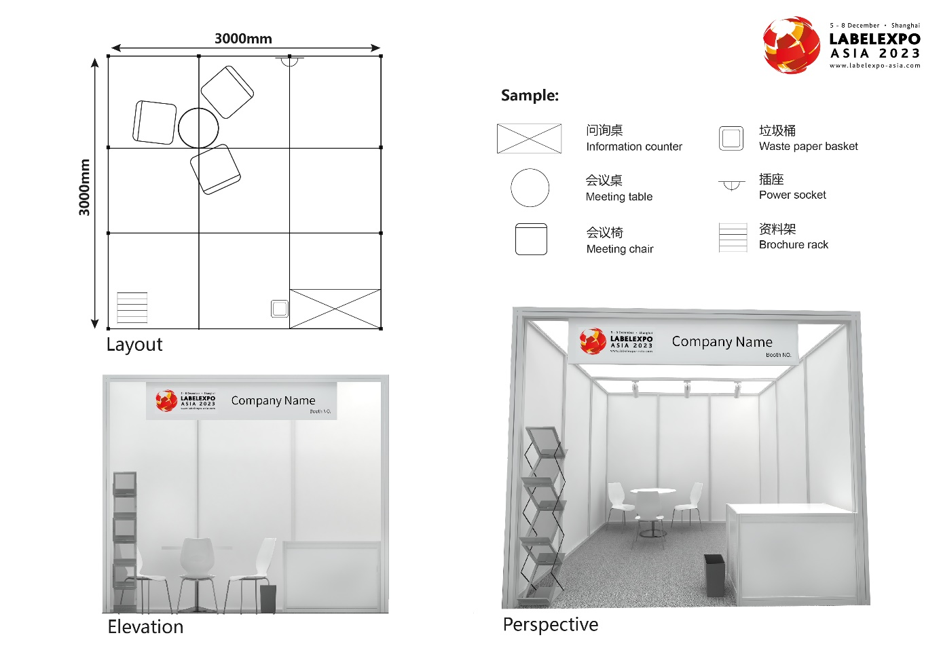

GRAPHICS
Please note that the shell scheme walls are made up of panels 2.47m high divided at 1m intervals with aluminium poles. PLEASE NOTE: the actual dimensions of each panel, for the purpose of applying graphics, is 950mm wide x 2330mm high. The maximum height for pop up displays within shell scheme stands is 2.47 metres (please see shell scheme diagram with dimensions above).
Please advise Claire Comery ccomery@labelexpo.com if you have any questions about fitting your display into your stand area.
If you wish to have graphics printed to fit within your shell scheme stand, our contractor, ChanYeer, are able to provide a full range of graphical options. Please contact:

ADDITIONAL SHELL SCHEME OPTIONS
Additional fittings and accessories for the shell scheme can be ordered through the ChanYeer e-system platform by 6th November 2023
PLEASE NOTE: All additional items are chargeable directly to the Exhibitor.

INTERIOR DISPLAYS ON SHELL SCHEME SITES
Exhibitors are at liberty to engage a contractor of their choice to carry out the construction and installation of interior displays on shell scheme stands provided that the name of the contractor appointed is submitted to the Organisers.
The official shell scheme contractors, ChanYeer, will, of course, be pleased to provide estimates for such work. Please note that all materials used for the construction of displays must be of a non-inflammable nature.
PLEASE NOTE: If you are ordering any extra items such as furniture, electrics or staffing etc please ensure that you make payment to the relevant contractor in full, in advance of the exhibition, to avoid delay onsite. In China, orders are not serviced unless full payment has been received.

CHANYEER E-SYSTEM PLATFORM
Please visit the ChanYeer e-system platform to access exhibitor services and place the orders
http://e.chanyeer.com/exhibitor
You will be sent the log in details to log in on the platform. If you need different log in details or if you have any questions regarding the e-system platform, please contact:
If you have any enquiries regarding the ChanYeer e-system platform, please contact:
Tony Gu
ChanYeer Group (China) Co Ltd Tel: + 86 21 6048 7372
Room 303, Bld 1, Block A, Lane 707 Fax: +86 21 5156 4085
Wuxing Rd, Pudong District, Email: tony.gu@chanyeer.com
Shanghai 201204, China

